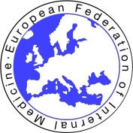 | The Foundation for the Development of Internal Medicine in Europe  and  The European Federation of Internal Medicine | 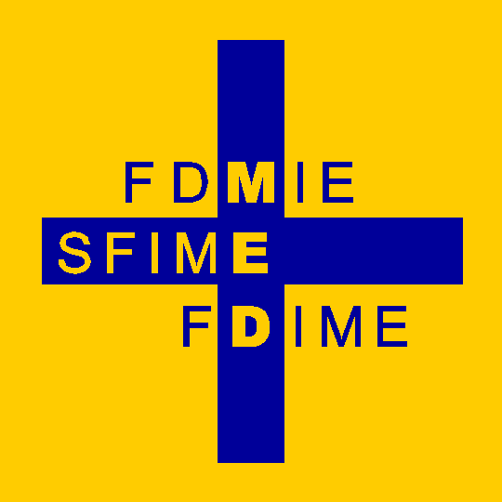

FDIME-EFIM 16th CLINICAL RESEARCH SEMINAR: 25 -27 October 2021

Venue : La Maison du Poumon, 66 boulevard Saint-Michel,
Jardin du Luxembourg, 75006 Paris, France

Seminar Schedule

Topics For The Course Will Include :

- ➢ Methodological, practical, and ethical issues in clinical trials
- ➢ Clinical epidemiology
- ➢ How to build a clinical trial
- ➢ Workshop of published and on-going trials
- ➢ Differences between industrial and institutional research
- ➢ How to write a medical paper
- ➢ How to write a winning grant application
        - ➢ Short presentations of their own experience by the residents

The structure of the course will permit interaction between residents and speakers, working in small groups on real life examples.

Sunday 24 October Residents Arrive by 19.00 hr at their Hotel located close to the Seminar venue. (Hotel bookings will be arranged for all attendees who will be advised accordingly).

20.00 – 20.30 hr Preliminary Introductions & Welcome at the Residents’ Hotel.
Residents will have free time after Welcome meeting.

Monday 25 October
09.00 - 09.15 Welcome coffee at the Seminar Venue
09.15 - 13.00 Clinical Research Seminar sessions
13.00 - 14.00 Buffet Lunch – on site
14.00 – 17.30 Clinical Research Seminar sessions
20.00 Informal Dinner for Residents & Speakers at a local Restaurant

Tuesday 26 October
08.45 - 12.30 Clinical Research Seminar sessions
12.30 - 13.30 Buffet Lunch – on site
13.30 - 18.00 Clinical Research Seminar sessions
20.00 Informal Dinner for Residents & Speakers at a local Restaurant.

Wednesday 27 October
09.00 - 12.45 Clinical Research Seminar sessions
12.45 - 13.30 Evaluation and Closing Remarks by Prof Daniel Sereni.
13.30 - 14.30 Buffet Lunch – on site
14.30 Free time - Residents Depart

